

WAMBAZA: A Multilingual Platform for Adolescent Sexual and Reproductive Health Guidance in Rwanda and Uganda Using Conversational Language Technologies

BSc. in Software Engineering

Ntakirutimana Pretty Diane

Supervisor: Emmanuel Adjei

Date: 31st May

Table of contents
ACRONYMS 5
ABSTRACT 6
CHAPTER ONE: INTRODUCTION 7
1.1 Introduction and Background 7
1.2 Problem statement 8
1.3 Project’s main objective 9
1.3.1 List of the specific objectives 9
1.4 Research questions 9
1.5 Project scope 10
1.6 Significance and Justification 11
1.7 Research budget 11
1.8 Research Timeline 11
CHAPTER TWO: LITERATURE REVIEW 13
2.1 Introduction 13
2.2 Historical Background of the Research Topic 13
2.3 Overview of Existing System 13
2.3.1 Summary of Reviewed Literature 15
2.4 Review of Related Work 16
2.5 Strengths and Weakness of the Existing System(s) 16
2.6 General comment and Conclusion 17
CHAPTER THREE: SYSTEM ANALYSIS AND DESIGN 18
3.1 Introduction 18
3.2 System requirements 18
3.3 System Architecture 19
3.4 NLP Model Design and Machine Learning 20
Model architecture 21
Data flow diagram 22
3.5 UML Diagrams 23
Use case diagram 23
Class Diagram 24
Sequence diagram 25
3.6 Development Tools 26
REFERENCES 28

List of Tables
1.7 Research budget 11
2.3.1 Summary of Reviewed Literature 16
3.6 Development Tools 25 27

List of Figures
1.8 Research Timeline 19
3.4 NLP Model Design and Machine Learning 20
Model architecture 21
Data flow diagram 22
3.5 UML Diagrams 23
Use case diagram 23
Class Diagram 24
Sequence diagram 25

ACRONYMS
Acronym | Definition
ASRH | Adolescent Sexual and Reproductive Health
NLP | Natural Language Processing
RAG | Retrieval-Augmented Generation
LaBSE | Language-Agnostic BERT Sentence Embeddings
mT5 | Multilingual Text-to-Text Transfer Transformer
PEFT | Parameter-Efficient Fine-Tuning
LoRA | Low-Rank Adaptation
HASH | Hub for Artificial Intelligence in Maternal, Sexual and Reproductive Health
ITU | International Telecommunication Union
WHO | World Health Organization
NISR | National Institute of Statistics of Rwanda
ROUGE | Recall-Oriented Understudy for Gisting Evaluation
BLEU | Bilingual Evaluation Understudy
NLLB | No Language Left Behind

ABSTRACT

Despite the significant progress made in the prevention and care of adolescent sexual and reproductive health in both countries, adolescent sexual and reproductive health (ASRH) continues to be a public health crisis in Rwanda and Uganda, with teenage pregnancy reaching 8% of girls aged 15-19 in Rwanda (National Institute of Statistics of Rwanda, 2025) and adolescent girls accounting for about one in three new HIV infections in Uganda each year (UNAIDS, 2023). Although there are digital platforms for ASRH in Rwanda (CyberRwanda, Tantine in Rwanda) (Hémono et al., 2024) and community based awareness programmes in Uganda (UNFPA Uganda, 2024), there is no existing system that offers intelligent multilingual question answering in the two major local languages of the two countries – Kinyarwanda and Luganda. The most advanced Rwanda-specific attempt cited 38% accuracy in ASRH Kinyarwanda, revealing a significant performance gap in local language ASRH AI (Munezero, 2025). This study is proposing with the name Wambaza (Kinyarwanda for 'you can ask me') a multilingual ASRH web based platform for adolescents in Rwanda and Uganda. It is a fine-tuned mT5-base sequence-to-sequence transformer trained on HASH dataset comprising 29,815 validated ASRH Question Answer Pairs (QAPs) from which approximately 3,000 Kinyarwanda pairs were machine translated and human verified using the twigane NLLB model (Bakunzi, 2025). The HASH dataset combined with the WHO ASRH guidelines are used to create a LangChain retrieval-augmented generation pipeline, which provides source grounded responses to the prompts, and uses a confidence scoring mechanism to funnel low-confidence responses to qualified health professionals. It is hypothesized that the joint multilingual approach that leverages the Bantu morphological similarities of both local languages (Thangaraj et al., 2024; Nzeyimana & Rubungo, 2022) would achieve > 70% correctness scores at the Kinyarwanda and Luganda level, and that the use of source grounded confidence scoring will meaningfully reduce health information inaccuracies delivered to adolescent users. Pilot testing will involve 50 - 100 secondary school adolescents in Kigali and Kampala.

CHAPTER ONE: INTRODUCTION

1.1 Introduction and Background
Adolescent sexual and reproductive health (ASRH) represents one of the most persistent public health challenges in East and Central Africa. Despite significant advances in healthcare delivery and digital infrastructure across Rwanda and Uganda, young people in both countries continue to face formidable barriers to accessing accurate, private, and culturally appropriate ASRH information. These barriers, rooted in cultural stigma, linguistic exclusion, limited youth-friendly services, and deeply entrenched taboos surrounding sexual health, leave millions of adolescents without the guidance they need during one of the most formative periods of their lives.
The scale of the problem is significant. In Rwanda, the seventh Rwanda Demographic and Health Survey confirmed that teenage pregnancy has risen from 5% in 2020 to 8% among girls aged 15 to 19 in 2025, with rates reaching 20% by age 19 (National Institute of Statistics of Rwanda, 2025). The same survey reports a decline in comprehensive HIV prevention knowledge among youth aged 15 to 24, underscoring the urgency of renewed ASRH education efforts targeted at adolescents. In Uganda, adolescent girls and young women account for approximately one third of all new HIV infections annually, and more than two thirds of young people newly diagnosed with HIV are girls (UNAIDS, 2023). Despite significant investments in HIV prevention and ASRH programming across both countries, new infections among young people are not declining as rapidly as among other age groups, indicating persistent gaps in accessible and actionable health guidance for adolescents (UNAIDS, 2023).
A central driver of this gap is the absence of linguistically inclusive, private, and youth-friendly information channels. Cultural silence surrounding sexual health is compounded by the fact that conversations about sexuality are frequently avoided within families due to shame, religious beliefs, and the fear that such discussion promotes promiscuity (Mbarushimana et al., 2021). In Rwanda, existing school-based and community peer education programmes have demonstrated meaningful improvements in ASRH knowledge, yet their reach remains limited by geographic and linguistic barriers (Nkurunziza et al., 2023). In Uganda, limited access to youth-friendly ASRH services in rural and peri-urban areas, compounded by stigma and discrimination, continues to prevent adolescents from seeking the guidance they need (UNFPA Uganda, 2024).
The emergence of conversational artificial intelligence and natural language processing (NLP) technologies presents a promising opportunity to complement existing ASRH interventions. AI-powered question-answering systems offer private, on-demand, stigma-free access to health information, particularly valuable for sensitive topics where face-to-face consultation carries social risk (Mills et al., 2023). Systematic reviews confirm that integrating digital tools into ASRH educational strategies targeting adolescents in Sub-Saharan Africa can contribute to improved public health outcomes when designed with cultural and linguistic context in mind (Alhassan et al., 2025). While important progress has been made through digital ASRH platforms across Rwanda and Uganda, a gap remains in providing intelligent, fine-tuned multilingual question answering in both Kinyarwanda and Luganda, the primary local languages of the two countries.
This project proposes Wambaza, a multilingual AI-powered web platform for ASRH guidance in English, Kinyarwanda, and Luganda. The name "Wambaza" means "you can ask me" in Kinyarwanda, reflecting the platform's core purpose: creating a safe, anonymous space for young people to ask the questions they cannot ask anywhere else. The platform's primary technical contribution is a fine-tuned multilingual sequence-to-sequence NLP model trained on the HASH dataset, a large, health-worker-validated corpus of 29,815 ASRH question-answer pairs (Babirye, 2026), extended with a Kinyarwanda subset generated through a systematic machine translation pipeline. The platform serves two audiences: anonymous adolescent users who ask ASRH questions and read verified health articles, and trusted health institutions who publish and manage that content.

1.2 Problem statement
Despite meaningful progress in digital health infrastructure and ASRH programming across Rwanda and Uganda, adolescents in both countries continue to face substantial barriers in accessing accurate, culturally appropriate, and linguistically inclusive health information. In Rwanda, the RDHS7 confirmed that 8% of girls aged 15 to 19 had ever been pregnant in 2025, rising sharply from under 1% at age 15 to 20% by age 19, while new HIV infections among adolescents and young women aged 15 to 24 account for approximately 24% of all new infections in Rwanda (National Institute of Statistics of Rwanda, 2025; UNAIDS, 2023). In Uganda, more than two thirds of young people newly diagnosed with HIV are girls (UNAIDS, 2023). Cultural taboos, fear of judgment, and the absence of linguistically inclusive information channels leave adolescents dependent on informal sources of health information, with documented consequences for reproductive health outcomes (Mbarushimana et al., 2021; Nkurunziza et al., 2023).
Existing digital ASRH solutions in Rwanda and Uganda have made important contributions to adolescent health access, yet critical gaps remain. CyberRwanda and Tantine have advanced ASRH awareness in Rwanda through digital content and FAQ-based platforms, while community programmes such as UNFPA Uganda outreaches and the YEAH! Model campaigns have extended ASRH education to hard-to-reach adolescents (Hémono et al., 2024; Munezero, 2025; UNFPA Uganda, 2024). However, none of these solutions provides on-demand, intelligent, multilingual question answering in Kinyarwanda or Luganda, and no AI-powered conversational ASRH system currently exists in Uganda.
The most technically advanced Rwanda-specific attempt, Nganiriza, demonstrated the potential of NLP for ASRH guidance but reported only 38% correctness in Kinyarwanda, evaluated on just ten participants, and does not support Luganda (Munezero, 2025). Both Kinyarwanda and Luganda belong to the Bantu language family and share deep morphological structures, presenting an opportunity for cross-lingual transfer learning that could strengthen model performance across both languages simultaneously (Thangaraj et al., 2024; Nzeyimana and Rubungo, 2022). This study introduces Wambaza, a multilingual AI-powered ASRH platform that builds on existing progress through a fine-tuned sequence-to-sequence NLP model trained on the HASH dataset (Babirye, 2026), extended with a translated Kinyarwanda subset and an anonymous web interface serving adolescents in Rwanda and Uganda.

1.3 Project’s main objective
Overall, the primary aim of this project is to build a multilingual AI powered question answering system, Wambaza, which provides accurate and linguistically accessible information on ASRH in English, Kinyarwanda and Luganda, while filling the identified gaps in existing ASRH digital solutions in Rwanda and Uganda through a fine-tuned sequence-to-sequence transformer model combined with a retrieval-augmented generation pipeline using validated ASRH knowledge sources.

1.3.1 List of the specific objectives
The specific objectives of this study are to:

- To survey the existing literature of multilingual tools on NLP and digital ASRH in Rwanda and Uganda, and to build a multilingual dataset of ASRH training data in English, Luganda and Kinyarwanda by extending the HASH ASRH dataset with a Kinyarwanda subset, created using a systematic machine translation pipeline and verified for linguistic and health accuracy.
- To create Wambaza, a more nuanced version of multilingual sequence-to-sequence NLP model with a LangChain retrieval-augmented generation pipeline, trained on the HASH dataset and WHO ASRH guidelines to deliver more accurate, source-grounded, and contextually appropriate answers for English, Kinyarwanda, and Luganda with a confidence scoring mechanism for low certainty responses to direct users to professional health care services, particularly exceeding the 38% Kinyarwanda correctness baseline reported by Nganiriza (Munezero, 2025).
- To assess Wambaza using both technical and real-world metrics, including ROUGE, BLEU, and BERTScore for model performance, a correctness rate comparison against the documented baseline correctness of 38% for Kinyarwanda, provided by Nganiriza, and to determine whether confidence scoring and source grounding meaningfully reduce the risk of delivering incorrect health information to adolescents in Rwanda and Uganda.

1.4 Research questions
- How do the features of verified ASRH knowledge sources, adapted to a retrieval-augmented generation pipeline, fit with a fine-tuned multilingual sequence-to-sequence model to accurately and culturally appropriately provide ASRH guidance for adolescents in Rwanda and Uganda in English, Kinyarwanda and Luganda?
- How much does the correctness of the Kinyarwanda responses to the dataset increase beyond the baseline of 38% accuracy achieved by the existing systems and what is the role of cross-lingual transfer learning between the two related Bantu languages Kinyarwanda and Luganda in the performance of the model in the two low-resource languages?
- What are the rates of correct responses to accurate ASRH information in English, Kinyarwanda and Luganda relative to existing baseline, and is the effective delivery of accurate information to users by using a combination of source grounding with confidence scoring less likely to result in the delivery of harmful or inaccurate health information to the users?

1.5 Project scope
This project will focus on testing the Wambaza platform within selected secondary schools in Kigali, Rwanda and Kampala, Uganda. This approach allows for manageable implementation while capturing diverse socioeconomic and cultural contexts across both target countries.
Target User Base: The pilot will aim to engage 50 to 100 adolescents aged 15 to 19 across the selected schools over a one-month testing period. This sample size will provide sufficient data for meaningful evaluation while remaining logistically feasible for initial platform deployment.
Technical Scope: The platform will be developed as a mobile-responsive web application integrating a fine-tuned multilingual sequence-to-sequence NLP model with a LangChain retrieval-augmented generation pipeline grounded in the HASH dataset and WHO ASRH guidelines. The system supports English, Kinyarwanda, and Luganda, uses multilingual LaBSE embeddings for cross-lingual retrieval, and includes a confidence scoring mechanism that flags low-certainty responses. A content management interface allows health professionals to publish verified ASRH articles. No user registration or personal data will be collected from adolescent users, ensuring full anonymity.
Content Scope: Initial health guidance will focus on foundational ASRH topics most relevant to adolescents in Rwanda and Uganda, including STIs, HIV and AIDS, contraception, puberty, and consent, with content expansion planned based on user needs identified during the pilot phase.
Out of Scope: Live web search, integration with external health systems, French language support, and large-scale national deployment are identified as future work beyond the current project timeline.

1.6 Significance and Justification
Upon successful implementation, the new ASRH guidance in these pilot schools in Kigali and Kampala will be in the preferred language of the adolescents, with responses based on accurate and trusted WHO guidelines and the HASH health-worker-validated ASRH dataset, thereby decreasing reliance on informal and unreliable sources of information, and potentially enhancing adolescent reproductive health knowledge and better health decisions.

The anonymity will reduce the stigma associated with seeking ASRH information which is currently high, and will provide a space for adolescents’ questions to which they are not afraid to ask their parent, teacher, health worker and which need to be asked. The confidence scoring mechanism also ensures that if the system is uncertain, it will direct users to the professional health care system instead of providing potentially harmful information.

Last, this project brings reusable resources and novel results to the African NLP research community, aiding in the development of health AI tools for Bantu language speakers in Africa in the future.

1.7 Research budget
Category | Item | Purpose | Cost (Rwf) | Duration
Cloud Computing | Google Colab Pro | Model training and NLP processing | 75,000 | 3 months
Cloud Infrastructure | Render | Web app hosting and deployment. | 60,000 | 3 months
Miscallaneous | Documentation and printing | Project documentation and user guides | 20,000 | One time
Table1: Research budget

1.8 Research Timeline
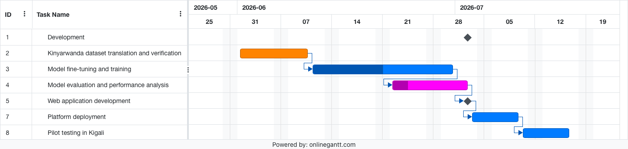

CHAPTER TWO: LITERATURE REVIEW

2.1 Introduction
This literature review aimed to identify software-based tools and/or systems that could assist in providing guidance on adolescent sexual and reproductive health (ASRH) in Rwanda and Uganda, with a special focus on AI-based, multilingual and conversational software systems. There is a well-established literature base on ASRH challenges worldwide and in Sub-Saharan Africa but few software developed for these challenges in the context of East and Central Africa that utilise linguistic adaptation and intelligent approaches. Some of the indexed platforms and databases examined are Google Scholar, ACL Anthology, ACM Digital Library, arXiv and PubMed. Twenty relevant publications were retrieved, with emphasis on papers published in peer-reviewed journals, conference papers, and official reports from institutional sources between 2020 and 2026, especially on papers dealing with the problems of ASRH in Rwanda and Uganda and software solutions.

2.2 Historical Background of the Research Topic
Local integration of software solutions in ASRH initiatives has been a significant development over the last decade, with the digital health, mobile, and AI revolution driving this change. Earlier ASRH initiatives were mostly based on the traditional methods such as brochures, in-school education, and direct counseling sessions. With the increasing reach of mobile and internet communications in Sub-Saharan Africa, SMS-based platforms, static mobile applications and online resources were increasingly used to enhance accessibility for ASRH interventions. In the context of Rwanda specifically, the government has taken a proactive step in recognizing the potential of technology to scale ASRH education by introducing programmes in the country's schools in addition to mobile-based programmes.In the specific context of Rwanda, there is early action to leverage technology to scale ASRH education through the introduction of programmes in schools as well as the mobile programmes (UNFPA Rwanda, 2025). Recent developments in natural language processing, multilingual transformer models, and AI-driven conversational systems have also begun to provide new opportunities to provide confidential, real-time, and linguistically inclusive ASRH guidance. The evolution aligns with the current trend of delivering culturally appropriate, tailored, and translated communication and information on ASRH for various linguistic groups in Africa, as highlighted by Alhassan et al. (2025).

2.3 Overview of Existing System
There are a number of software systems and awareness programmes designed for ASRH guidance for adolescents in Rwanda and Uganda which contribute meaningfully to the field.
CyberRwanda is a youth-focused digital health intervention that delivers ASRH information, e-learning content, health-facility locator, and a fully featured FAQ library in Rwanda. It was developed by YLabs in collaboration with Society for Family Health Rwanda, and piloted in 60 secondary schools across 8 districts with 6,078 adolescents aged 12-19. At 12 months, the trial showed that there were significant gains in ASRH knowledge, attitudes, self-efficacy and behavior (Hémono et al., 2024). To date, CyberRwanda is the most rigorously tested digital ASRH platform in Rwanda. Similarly, the Tantine platform offers awareness on ASRH as well as counselling through interactive storytelling and using FAQs, with the youth-friendly digital interface contributing to adolescent health access (Munezero, 2025). Currently, there is no AI-based conversational ASRH system in Uganda. Community-based programmes are the main approach to ASRH education, such as the integrated ASRH outreaches by UNFPA Uganda for hard-to-reach adolescents in Northern Uganda in a rural and refugee context (UNFPA Uganda, 2024), and the YEAH! Adopting community engagement, health service delivery, and radio talk shows as a multi-faceted approach to addressing teenage pregnancy, HIV, and gender-based violence (GBV) through model district-level SRHR campaigns co-implemented by UNFPA Rwanda and the Ministry of Youth and Arts (UNFPA Rwanda, 2025). These programs have helped to reach hard-to-reach teens with ASRH education, but they are limited geographically, cannot be scaled to outside of their pilot programs, and lack on-demand digital access in local language.
Nganiriza is the most technically sophisticated Rwanda-specific solution to this gap with its multilingual conversational AI that offers ASRH guidance in both Kinyarwanda and English. Nganiriza has indicated the possibility of NLP in the context of ASRH communication reporting a correctness rate of 72% in the English language. But Kinyarwanda performance was significantly lower at 38%, partly due to limited training data and the lack of fine-tuning in low-resource language settings, and only tested on ten participants (Munezero, 2025). In addition, Nganiriza doesn't offer any support to Luganda thus leaving the Ugandan adolescents with no equivalent support.

2.3.1 Summary of Reviewed Literature
System / Study | Type | Country | Languages | Key Contribution | Limitation
CyberRwanda (Hémono et al., 2024) | Digital health platform | Rwanda | English, Kinyarwanda | Rigorous RCT, improved ASRH knowledge | No NLP, rule-based FAQ
Tantine (Munezero, 2025) | Web and mobile app | Rwanda | Kinyarwanda, English | Youth-friendly ASRH awareness | Static, no AI capability
Nganiriza (Munezero, 2025) | Conversational AI | Rwanda | English, Kinyarwanda | NLP-based ASRH guidance | 38% Kinyarwanda accuracy, 10 users, no Luganda
UNFPA Uganda outreaches (UNFPA Uganda, 2024) | Awareness programme | Uganda | Luganda, English | Reaches rural and refugee youth | Not digital, not scalable
YEAH! Model (UNFPA Rwanda, 2025) | Awareness campaign | Rwanda | Kinyarwanda, English | Community ASRH engagement | Not digital, geographically limited
KinyaBERT (Nzeyimana and Rubungo, 2022) | NLP model | Rwanda | Kinyarwanda | Morphology-aware Kinyarwanda model | Not applied to health QA
HASH/Zindi challenge (Babirye, 2026) | NLP dataset and challenge | Uganda/Pan-African | Luganda, Kiswahili, Akan, Amharic, English | Validated multilingual ASRH QA dataset | No Kinyarwanda subset
Table2: Reviewed literature

2.4 Review of Related Work
In terms of a crosslingual open-retrieval dataset for African languages, AfriQA (Ogundepo et al., 2023) is the first dataset of this kind for African languages, such as Kinyarwanda, highlighting the lack of in-language coverage for low-resource African languages and the poor performance of automatic translation as an alternative to in-language training data. Spoken in Rwanda, Kinyarwanda is a Bantu language with a large vocabulary. KinyaBERT (Nzeyimana and Rubungo, 2022) proposes a new morphology-aware language model designed specifically for Kinyarwanda that outperforms multilingual baselines on the basis that shared multilingual tokenizers are detrimental to morphologically rich Bantu languages. The work has direct implications for the model design decisions in Wambaza, where the morphological complexity of the Kinyarwanda language needs to be taken into consideration in the tokenization and fine-tuning process.
Fine-tuned models have been used when testing cross-lingual transfer from Bantu languages, with up to 88.3% accuracy in test tasks of translating Kinyarwanda to Kirundi, which suggests the possibility of improving the performance of both languages by exploiting their structural similarity between both languages. The challenge was developed by Makerere University in partnership with Zindi and ITU, and consisted of a curated collection of QA pairs for ASRH written in Luganda, Kiswahili, Akan, and Amharic, measured by ROUGE and LLM-as-a-judge. This data set and evaluation framework are the foundation of Wambaza's training tool. The technical difficulty and the research potential in this area were further highlighted by KenSwQuAD (Wanjawa et al., 2023) which showed that fine-tuned multilingual models on low-resource African QA datasets only outperform the English models with F1 scores of 59.4%, which is far from the English scores.

2.5 Strengths and Weakness of the Existing System(s)
In Rwanda and Uganda, there are existing ASRH software systems and programmes, which have shown key strengths. In the Rwandan school setting, CyberRwanda demonstrated, based on rigorous randomized trial evidence, that digital ASRH platforms can meaningfully influence adolescent health knowledge, attitudes, and self-efficacy. Based on rigorous randomized trial evidence, CyberRwanda showed that digital ASRH platforms can meaningfully influence adolescent health knowledge, attitudes, and self-efficacy in the Rwandan school context (Hémono et al., 2024). UNFPA Uganda outreaches and the YEAH! are community based programmes. Evidence has demonstrated that it is possible to reach underserved adolescents with ASRH information, even in hard to reach geographic contexts (UNFPA Uganda, 2024; UNFPA Rwanda, 2025). On the NLP side, KinyaBERT and AfriQA have demonstrated the technical potential of creating high-quality language models for Kinyarwanda (Nzeyimana and Rubungo, 2022) and for African languages in general (Ogundepo et al., 2023), respectively, and the HASH data has contributed to establishing a multilingual ASRH QA corpus that is validated for use (Babirye, 2026).
There are still some important gaps. No deployed system offers on-demand, intelligent, multilingual ASRH question answering in both Kinyarwanda and Luganda. While awareness programmes can be community based and effective, they cannot be scaled and there is no private, anonymous digital access. The most developed conversational ASRH system tested was Nganiriza which scored a correct rate of 38% in Kinyarwanda, and was not tested in Uganda (Munezero, 2025). Although these two languages provide strong models and datasets in the academic setting, no deployed ASRH question answering application has been created for them. This gap between NLP research potential and deployed health software is the focal point of this project.

2.6 General comment and Conclusion
The literature review shows that both Rwanda and Uganda have significant achievements in ASRH programming, including digital tools, community outreach, and government-led education and training programs; however, there is a significant gap in providing intelligent, multilingual, on-demand information in Kinyarwanda and Luganda. Current computer programs have been either rule-based and language restricted, or geographically confined and not computer-readable. On the other hand, studies on NLP in Africa have yielded more and more effective multilingual models and validated datasets, which have not been deployed as an ASRH question-answering application for these two languages. The lack of an AI-powered ASRH system in Uganda, coupled with Nganiriza's 38% Kinyarwanda correctness rate, underscores the need for developing Wambaza, which is a fine-tuned multilingual system for ASRH question-answering based on the HASH dataset with an additional subset of kinyarwanda questions translated from Swahili and rigorously validated using established NLP metrics.

CHAPTER THREE: SYSTEM ANALYSIS AND DESIGN

3.1 Introduction

The Wambaza platform is a multilingual AI powered adolescent sexual and reproductive health (ASRH) guidance platform in Rwanda and Uganda, which is described in this chapter. It depicts the following system architecture, functional and non functional requirements, machine learning and natural language processing techniques, system workflow, database structure and implementation tools. In addition, it illustrates how the system components interact among each other to provide culturally appropriate information in English, Kinyarwanda and Luganda.

3.2 System requirements

Functional requirements
- Users can submit ASRH questions anonymously in English, Kinyarwanda, or Luganda and receive contextually appropriate and accurate responses without creating an account.
- The system automatically detects the input language and generates responses in the same language as the question.
- Before generating a response, the system retrieves the most semantically relevant content from the HASH dataset and WHO ASRH guidelines using a LangChain retrieval-augmented generation pipeline, grounding every answer in verified health knowledge.
- Each generated response is accompanied by a confidence score derived from the model's output probabilities. Responses falling below a defined confidence threshold display a fallback message directing the user to consult a qualified health professional.
- Health institution administrators can log in securely to upload, review, and publish verified ASRH articles accessible to platform users.
- Administrators can moderate published content and monitor system performance through an admin dashboard.
Non-functional requirements
- Performance: Response time under 3 seconds for most queries under normal load conditions.
- Accuracy: Target correctness rate above 70% in Kinyarwanda and Luganda, directly surpassing Nganiriza's documented 38% Kinyarwanda baseline (Munezero, 2025).
- Security and Privacy: Full anonymity for public users with no account required for querying, end-to-end encryption of all data in transit, and compliance with Rwanda's Law No. 058/2021 on Personal Data Protection and Uganda's Data Protection and Privacy Act 2019.
- Usability: Simple, mobile-responsive interface suitable for low-bandwidth environments in Rwanda and Uganda, requiring no technical literacy from adolescent users.
- Scalability: Designed to handle up to 10,000 concurrent users with cloud-based horizontal scaling on Render.
- Reliability: 99% uptime with fallback mechanisms ensuring the system never leaves a user without a response, even when model confidence is low.

3.3 System Architecture
Wambaza follows a modular architecture with a clear separation between the frontend, backend, AI inference layer, RAG pipeline, and data storage layers. This design supports maintainability, independent component testing, and future expansion to additional languages or health domains.
- Frontend Layer: A React and Tailwind CSS web application with a responsive, mobile-first design. The interface presents a simple anonymous chat input for adolescent users and a separate authenticated interface for health institution administrators. Responses are displayed alongside confidence indicators and source references.
- API Gateway: A Flask-based API gateway handles all routing, rate limiting, and administrator authentication. Anonymous public users bypass authentication entirely, ensuring frictionless access for adolescents.
- Backend Services: Python and Flask coordinate requests between the frontend and the AI inference layer, manage administrator content workflows, and handle article storage and retrieval.
- Language Detection Module: fastText identifies the input language automatically and routes the query to the appropriate language processing pipeline, supporting English, Kinyarwanda, and Luganda.
- LangChain RAG Pipeline: The core intelligence layer. LangChain orchestrates the following steps for every user query: the question is converted into a multilingual vector embedding using LaBSE, the vector is used to search ChromaDB for the most semantically relevant content chunks from the HASH dataset and WHO ASRH guidelines, and the retrieved chunks together with the original question are passed to the fine-tuned mT5 model as a structured prompt. This grounding step ensures that generated answers are rooted in verified health knowledge rather than model memory alone.
- Confidence Scoring Module: After the model generates a response, the average softmax probability of the output token sequence is computed. If this score falls below a defined threshold, the system appends the message: "I am not fully confident in this answer. Please consult a qualified health professional for accurate guidance."
- Vector Database: ChromaDB stores multilingual LaBSE embeddings of the HASH dataset Q&A pairs and WHO ASRH guideline chunks. This database is built once offline and queried in milliseconds at inference time with no live internet access required.
- Relational Database: PostgreSQL stores administrator accounts, published ASRH articles, and anonymized system performance logs.
- Deployment: Both the frontend and backend are hosted on Render, which deploys directly from GitHub and provides sufficient capacity for the pilot scale of 50 to 100 users.

3.4 NLP Model Design and Machine Learning
The core of Wambaza will use a transformer-based sequence to sequence model. Some possible architecture models include mT5, mBART, AfroXLMR, MarianMT for low-resource languages. The selected model will be fine-tuned using the multilingual SRH dataset.

Model Development Pipeline:

- Base model: mT5-base — multilingual seq2seq transformer supporting English, Kinyarwanda, and Luganda natively.
- Dataset preparation: HASH dataset (29,815 Q&A pairs) extended with ~3,000 Kinyarwanda training pairs and ~700 validation pairs translated using the twigane NLLB model (Bakunzi, 2025), with 200 pairs manually verified by the researcher.
- Fine-tuning: Parameter-efficient fine-tuning using LoRA, with joint multilingual training across all three languages to leverage cross-lingual Bantu transfer between Kinyarwanda and Luganda (Thangaraj et al., 2024).
- RAG pipeline: LangChain orchestrates LaBSE multilingual embeddings and ChromaDB retrieval over the HASH dataset and WHO ASRH guidelines before answer generation.
- Confidence scoring: Softmax output probabilities attached to every response, with low-confidence responses triggering a referral message to a qualified health professional.
- Evaluation metrics: ROUGE, BLEU, BERTScore, and human-evaluated correctness rate compared against Nganiriza's 38% Kinyarwanda baseline (Munezero, 2025).

Model architecture
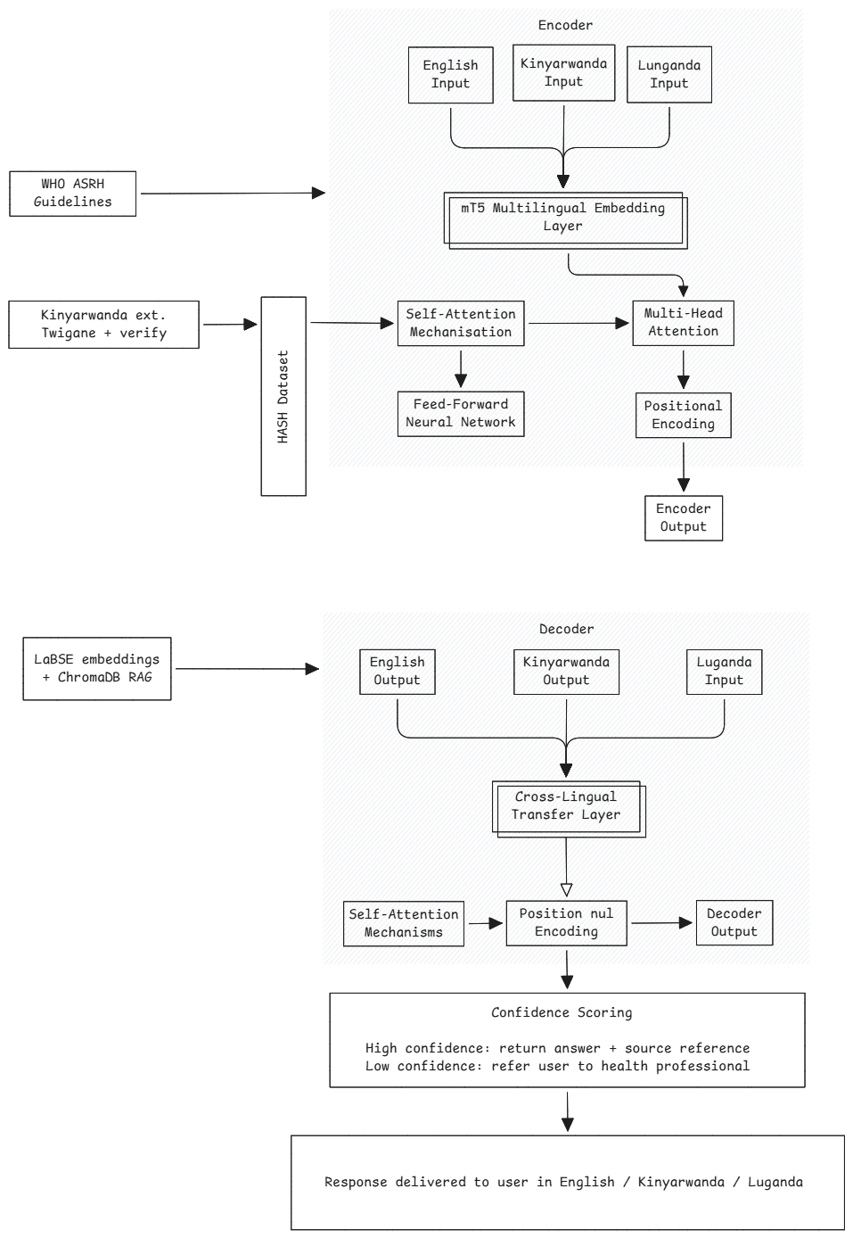

How the System Works :
- Users submit an ASRH question anonymously via the web chat interface in English, Kinyarwanda, or Luganda.
- The system automatically detects the input language and tokenizes the query.
- LaBSE converts the query into a multilingual vector embedding and ChromaDB retrieves the most relevant chunks from the HASH dataset and WHO ASRH guidelines.
- The fine-tuned mT5 model generates a grounded answer using the retrieved chunks and the original question as input.
- A confidence score is computed from the model's softmax output probabilities.
- If confidence is above the threshold, the answer is returned alongside a source reference.
- If confidence is below the threshold, the user receives a message directing them to consult a qualified health professional.
- The response is displayed in the chat interface in the same language as the question.
- Health institution administrators can log in to publish new verified ASRH articles, expanding the knowledge base over time.

Data flow diagram
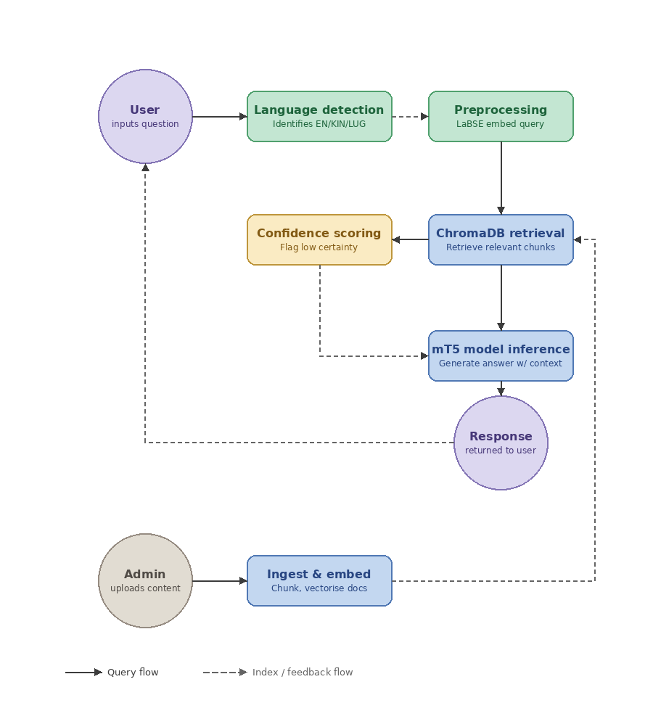
3.5 Security and Ethical Considerations
- All user queries are processed without storing personally identifiable information, and no account or registration is required for adolescent users to access the platform. All data in transit is encrypted using HTTPS.
- The confidence scoring mechanism provides an additional safety layer, ensuring that low-certainty responses are flagged and users are directed to qualified health professionals rather than receiving potentially harmful information.
- AI-generated responses are grounded in verified sources, the HASH dataset and WHO ASRH guidelines, to minimize the risk of misinformation.

3.5 UML Diagrams

Use case diagram
The use case diagram below describes who uses the Wambaza system and what actions they are permitted to perform.
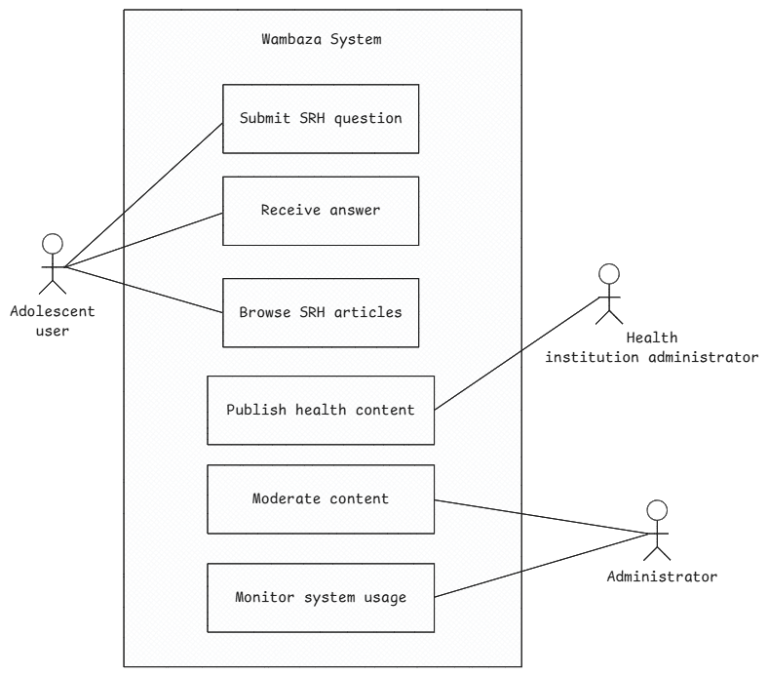

Class Diagram
The diagram below shows the structure of the code. Each box is a class, listing its attributes and methods. The lines between classes show how they relate, which class is related to the other, and in what quantity.
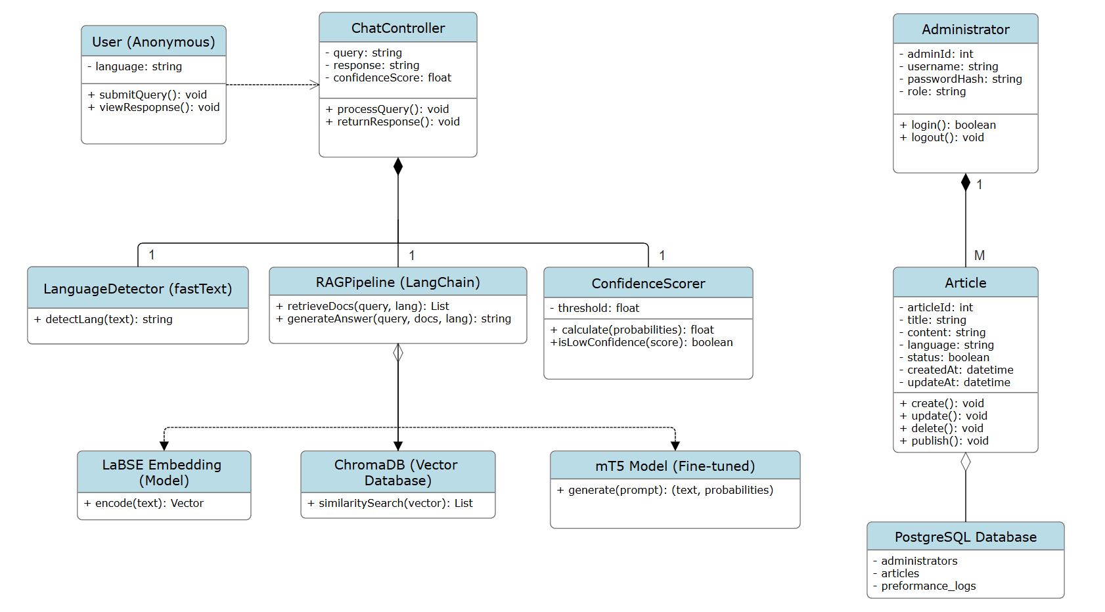

ERD (Entity Relationship Diagram) is showing the database structure. The tables, the fields, and the cardinalities.
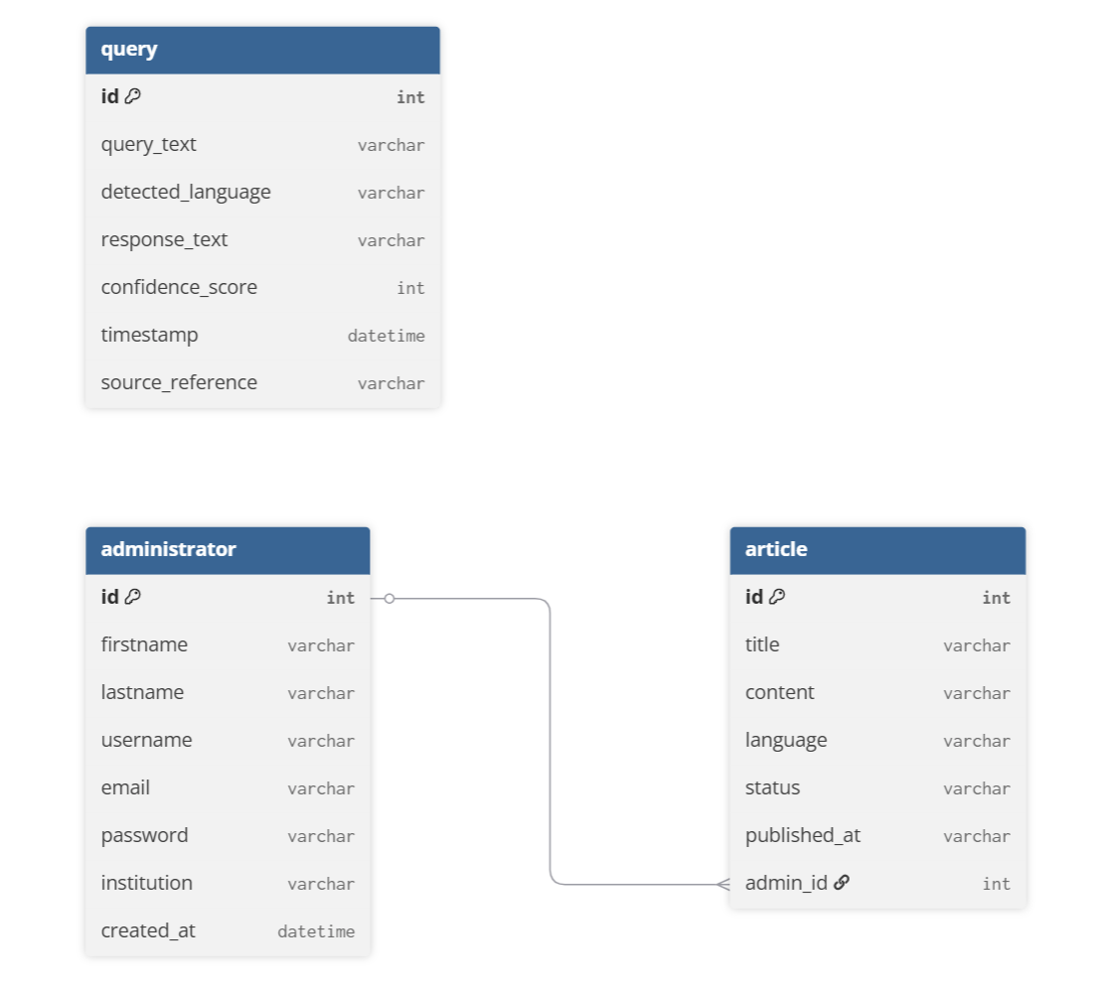

Sequence diagram
The sequence diagram below is showing how the system behaves over time for one specific scenario. It is tracing a single user query from start to finish, showing which component talks to which, in what order, and what gets returned.

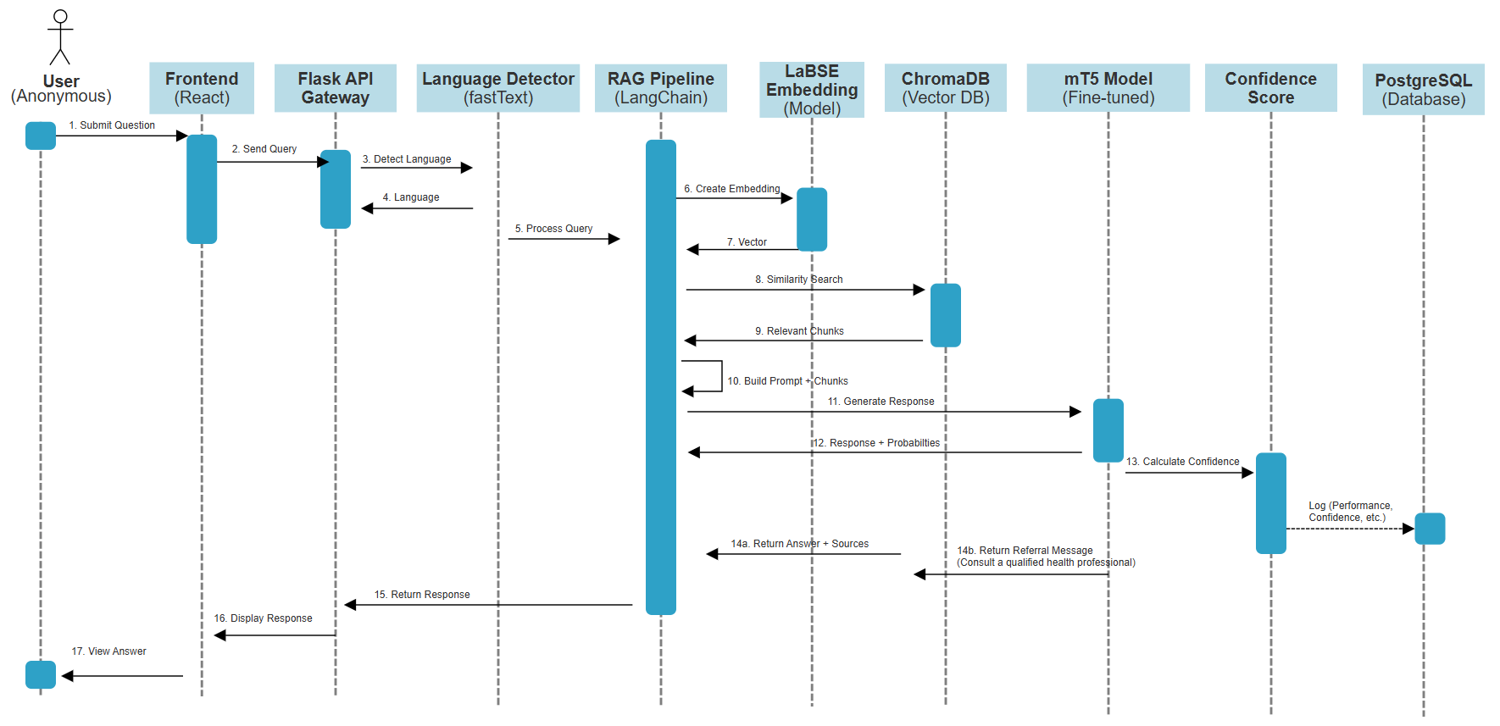

3.6 Development Tools
The following tools and technologies are used in the development and deployment of Wambaza.
Category | Tool / Technology | Justification
Frontend | React, Tailwind CSS | Responsive, mobile-first UI for low-bandwidth environments
Backend | Python, Flask | Lightweight, high performance for AI integration
NLP Framework | Hugging Face Transformers, PyTorch | Industry standard for seq2seq fine-tuning
Base Model | mT5-base | Multilingual, supports Kinyarwanda and Luganda, feasible on Colab
Fine-tuning | PEFT with LoRA | Reduces GPU memory requirements, enables Colab training
RAG Framework | LangChain | Orchestrates retrieval, prompt construction, and model inference
Embeddings | LaBSE | Cross-lingual embeddings supporting 109 languages including Kinyarwanda and Luganda
Vector Database | ChromaDB | Lightweight, local, no cost, suitable for pilot scale
Relational Database | PostgreSQL | Stores articles and admin data
Translation | twigane NLLB model | English to Kinyarwanda translation for dataset extension
Language Detection | fastText | Fast, accurate, supports low-resource languages
Deployment | Render | Free tier sufficient for pilot, deploys directly from GitHub
Model Training | Google Colab Pro | GPU access for fine-tuning within project budget
Table 3: development tools

REFERENCES
- Alhassan, R. H. A. H., Haggerty, C. L., Fapohunda, A., Affan, N. J., & Anto-Ocrah, M. (2025). Exploring the use of digital educational tools for sexual and reproductive health in Sub-Saharan Africa: Systematic review. JMIR Public Health and Surveillance. https://doi.org/10.2196/63309
- Babirye, C. (2026). Multilingual health question answering in low-resource African languages challenge [Zindi challenge webinar presentation]. Makerere University, COCIS.
- Bakunzi, M. (2025). twigane-en-kin-translation [Model]. Hugging Face. https://huggingface.co/Maxime-Bakunzi/twigane-en-kin-translation
- Hémono, R., Gatare, E., Kayitesi, L., Packel, L., Hunter, L. A., Kunesh, J., Mwali, M. M., Bertozzi, S., Sayinzoga, F., Mugisha, M., Hope, R., & McCoy, S. I. (2024). CyberRwanda's pathway to impact: Results from a cluster-randomized trial of adolescent family planning knowledge, beliefs, self-efficacy, and behavior. Journal of Adolescent Health, 74(6), 1239–1248. https://doi.org/10.1016/j.jadohealth.2024.01.035
- Mbarushimana, V., Conco, D. N., & Goldstein, S. (2021). Such conversations are not done in the families: A qualitative study of the determinants of early adolescents' access to sexual and reproductive health and rights information in Rwanda. Research Square. https://doi.org/10.21203/rs.3.rs-1043620/v1
- Mills, R., Mangone, E. R., Lesh, N., Mohan, D., & Baraitser, P. (2023). Chatbots to improve sexual and reproductive health: Realist synthesis. JMIR mHealth and uHealth. https://doi.org/10.2196/46761
- Munezero, E. (2025). NGANIRIZA: A multilingual platform for sexual and reproductive health guidance in Rwanda using conversational language technologies [BSc dissertation]. African Leadership University.
- National Institute of Statistics of Rwanda. (2025). Rwanda demographic and health survey 2025: Key indicators report (RDHS7). NISR. https://statistics.gov.rw
- Nkurunziza, A., Umubyeyi, A., & Mogren, I. (2023). Peer education programme to improve adolescent sexual and reproductive health in Rwanda. Reproductive Health, 20(1). https://pmc.ncbi.nlm.nih.gov/articles/PMC12587188/
- Nzeyimana, A., & Rubungo, A. N. (2022). KinyaBERT: A morphology-aware Kinyarwanda language model. Proceedings of the 60th Annual Meeting of the Association for Computational Linguistics. https://aclanthology.org/2022.acl-long.367
- Ogundepo, O., Osei, P., Elmadany, A., Hagos, L., Hooker, S., Bhatt, B., & Maganga, G. (2023). AfriQA: Cross-lingual open-retrieval question answering for African languages. Findings of EMNLP 2023. https://arxiv.org/abs/2305.06897
- Thangaraj, S., Ndagijimana, J., & Niyongabo, E. (2024). Cross-lingual transfer of multilingual models on low resource African languages. arXiv. https://arxiv.org/pdf/2409.10965
- UNAIDS. (2023). The path that ends AIDS: 2023 UNAIDS global AIDS update. https://www.unaids.org
- UNFPA Rwanda. (2025). Empowering Rwanda's youth: Strengthening SRHR awareness through community engagement. https://rwanda.unfpa.org
- UNFPA Uganda. (2024). Reaching adolescents and youth with integrated SRHR services through community outreaches in Northern Uganda. https://uganda.unfpa.org
- Wanjawa, B. W., Waweru, P., Ogolla, S., Muchemi, L., & Kimani, E. (2023). KenSwQuAD: A question answering dataset for Swahili low-resource language. ACM Transactions on Asian and Low-Resource Language Information Processing. https://dl.acm.org/doi/10.1145/3578553

